

|  |
| --- |
| Mockups del sistema |
| 16/11/16 11:08 |
| **Author:** John Doe  **File name:** Mockups del sistema.vp  **Version** 1.0 |

|  |
| --- |
| Site Map |
|  |

|  |
| --- |
|  |

01. Site Map / Mockups del sistema 

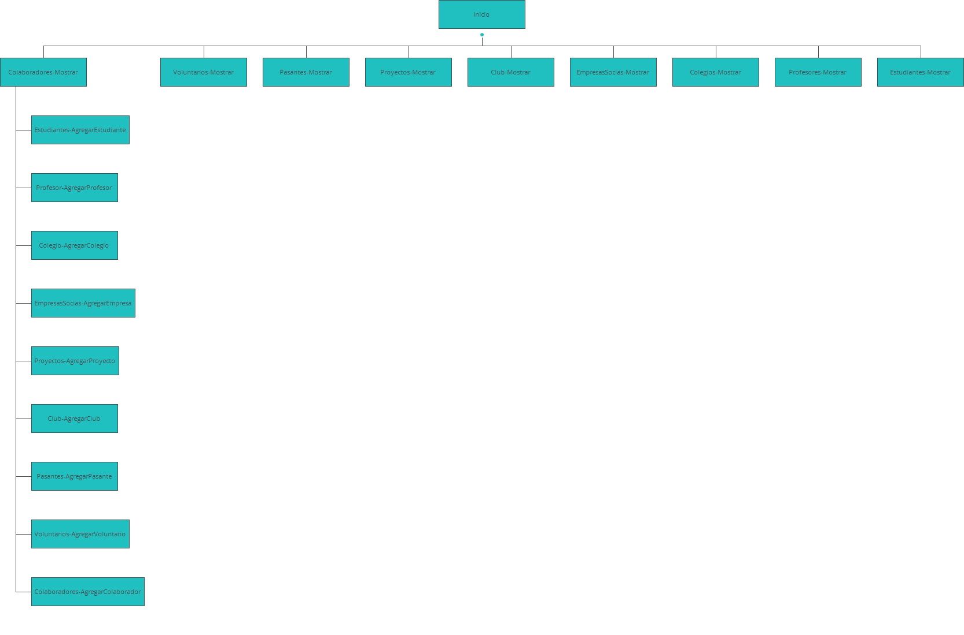

|  |
| --- |
| Screens |
|  |

|  |
| --- |
|  |

02. Screens / Mockups del sistema 

Club-AgregarClub

|  |
| --- |
|  |

02. Screens / Mockups del sistema 

Club-Mostrar

|  |
| --- |
|  |

02. Screens / Mockups del sistema 

Club-VisualizarClub

|  |
| --- |
|  |

02. Screens / Mockups del sistema 

Colaboradores-AgregarColaborador

|  |
| --- |
|  |

02. Screens / Mockups del sistema 

Colaboradores-Mostrar

|  |
| --- |
|  |

02. Screens / Mockups del sistema 

Colaboradores-VisualizarColaborador

|  |
| --- |
|  |

02. Screens / Mockups del sistema 

Colegio-AgregarColegio

|  |
| --- |
|  |

02. Screens / Mockups del sistema 

Colegio-VisualizarColegio

|  |
| --- |
|  |

02. Screens / Mockups del sistema 

Colegios-Mostrar

|  |
| --- |
|  |

02. Screens / Mockups del sistema 

EmpresasSocias-AgregarEmpresa

|  |
| --- |
|  |

02. Screens / Mockups del sistema 

EmpresasSocias-Mostrar

|  |
| --- |
|  |

02. Screens / Mockups del sistema 

EmpresasSocias-VisualizarEmpresa

|  |
| --- |
|  |

02. Screens / Mockups del sistema 

Estudiantes-AgregarEstudiante

|  |
| --- |
|  |

02. Screens / Mockups del sistema 

Estudiantes-Mostrar

|  |
| --- |
|  |

02. Screens / Mockups del sistema 

Estudiantes-VisualizarEstudiante

|  |
| --- |
|  |

02. Screens / Mockups del sistema 

Inicio

|  |
| --- |
|  |

02. Screens / Mockups del sistema 

Pasantes-AgregarPasante

|  |
| --- |
|  |

02. Screens / Mockups del sistema 

Pasantes-Mostrar

|  |
| --- |
|  |

02. Screens / Mockups del sistema 

Pasantes-VisualizarPasante

|  |
| --- |
|  |

02. Screens / Mockups del sistema 

Profesor-AgregarProfesor

|  |
| --- |
|  |

02. Screens / Mockups del sistema 

Profesores-Mostrar

|  |
| --- |
|  |

02. Screens / Mockups del sistema 

Profesores-VisualizarProfesor

|  |
| --- |
|  |

02. Screens / Mockups del sistema 

Proyectos-AgregarProyecto

|  |
| --- |
|  |

02. Screens / Mockups del sistema 

Proyectos-Mostrar

|  |
| --- |
|  |

02. Screens / Mockups del sistema 

Proyectos-VisualizarProyecto

|  |
| --- |
|  |

02. Screens / Mockups del sistema 

Voluntarios-AgregarVoluntario

|  |
| --- |
|  |

02. Screens / Mockups del sistema 

Voluntarios-Mostrar

|  |
| --- |
|  |

02. Screens / Mockups del sistema 

Voluntarios-VisualizarVoluntario

|  |
| --- |
|  |

|  |
| --- |
| Templates |
|  |

|  |
| --- |
|  |

03. Templates / Mockups del sistema 

960 grid - 12 columns

|  |
| --- |
|  |

03. Templates / Mockups del sistema 

960 grid - 16 columns

|  |
| --- |
|  |

03. Templates / Mockups del sistema 

Template 1

|  |
| --- |
|  |

|  |
| --- |
| Scenarios |
|  |

|  |
| --- |
|  |

04. Scenarios / Mockups del sistema 

default

|  |
| --- |
|  |

|  |
| --- |
| Data Masters |
|  |

|  |
| --- |
|  |

05. Data Masters / Mockups del sistema 

Clubs

|  |  |  |
| --- | --- | --- |
| Attribute name | Type | Values |
| IdClub | text | values |
| Club | text | values |
| Proyecto | text | values |

Colaboradores

|  |  |  |
| --- | --- | --- |
| Attribute name | Type | Values |
| Id | text | values |
| Apellidos Colaborador | text | values |
| Nombres Colaborador | text | values |
| Cargo | text | values |

Colegios

|  |  |  |
| --- | --- | --- |
| Attribute name | Type | Values |
| Colegio | text | values |
| Proyecto | text | values |
| Director | text | values |

EmpresasSocias

|  |  |  |
| --- | --- | --- |
| Attribute name | Type | Values |
| Nombre de la Empresa | text | values |
| Contacto | text | values |
| Telefono | text | values |

Estudiantes

|  |  |  |
| --- | --- | --- |
| Attribute name | Type | Values |
| Apellidos | text | values |
| Nombres | text | values |
| Colegio | text | values |
| Club | text | values |

Pasantes

|  |  |  |
| --- | --- | --- |
| Attribute name | Type | Values |
| ID | text | values |
| Apellidos | text | values |
| Nombres | text | values |
| Universidad | text | values |

Profesores

|  |  |  |
| --- | --- | --- |
| Attribute name | Type | Values |
| Apellidos | text | values |
| Nombres | text | values |
| Colegio | text | values |

Proyectos

|  |  |  |
| --- | --- | --- |
| Attribute name | Type | Values |
| IDProyecto | file upload | values |
| Proyecto | text | values |
| Empresa Socia | text | values |
| Coordinador | text | values |

Voluntarios

|  |  |  |
| --- | --- | --- |
| Attribute name | Type | Values |
| Apellidos | text | values |
| Nombres | text | values |
| Organizacion de Origen | text | values |

|  |
| --- |
| Requirements |
|  |

|  |
| --- |
|  |